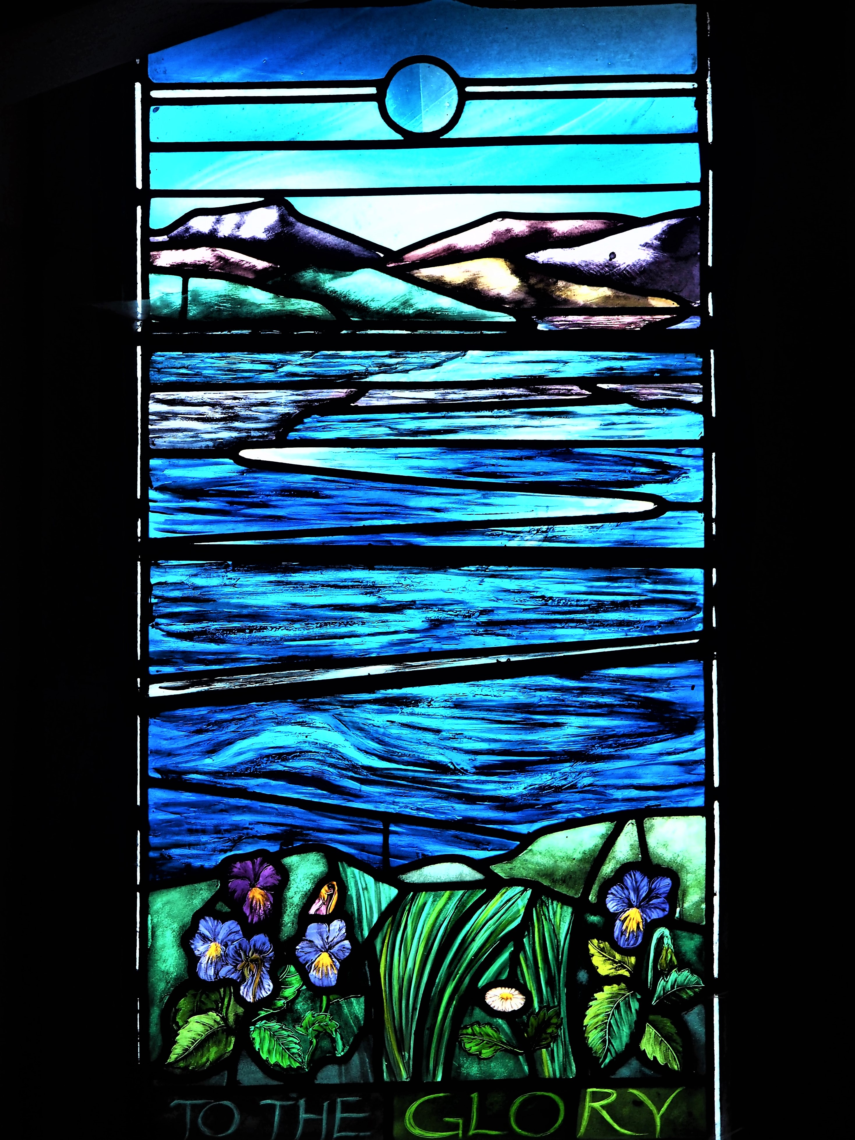  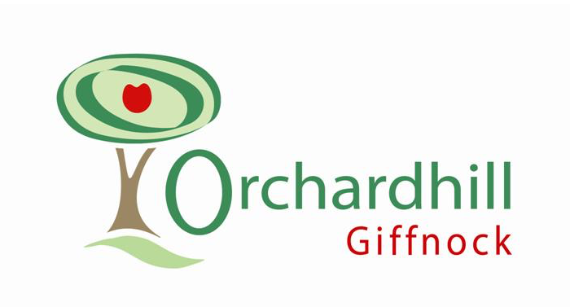 | THE RECORD
Faith for Treadmills
Rarely has there been such a temptation to get a previous Minister’s Letter off the shelf and re-publish it almost without alteration. Our present situation seems similar to that which informed my contribution to February’s Record on the then-brink of Brexit.
However, present repeating circumstances offer insight on a more general issue. What do we do when we find ourselves in the same place time after time? How do we live through the long, similar days of tests and appointments as we wait to be told what’s really wrong? How do we cope when, hour after hour, we can’t manage what once we took for granted? What do we make of those situations of family or finance when the same stresses seem, unflinchingly, to resist our best efforts to address them?
Perseverance is a large and often-repeated idea in Christian faith. Several New Testament letters encourage it among the early Christians, who found persecution was both demanding and unlikely to change. The angel of the church in Ephesus congratulates who have kept going and have not grown weary. It is, though, easier said than done.
In my early teenage years I visited, infrequently enough to make me feel guilty but sufficiently often to get to know, a Miss Sneddon. Badly affected by arthritis, she was confined to her chair in the front room on Armadale’s West Main Street. Sitting there, I looked past her to the street with people passing by. The contrast between easy freedom and imprisonment struck me, even as a youngster.
Over years of visiting I discovered things weren’t so straightforward. Miss Sneddon was warm and welcoming, with a sharp sense of humour, a keen concern for folk and a winning smile. Many people popped in: she heard, and remembered, news about from across the town and among its people. There was a freedom and liveliness in listening and learning which transcended her confinement. I often left more energised than when I had arrived.
There are few easy, and no good, answers to chronic challenge. Faith in a God who, in Christ, is at times frustrated and hard-pressed - and is eventually confined and crucified - may give us other ways of seeing beyond present difficulties to other possibilities. And it may be no coincidence that one of the characteristics of love is that ‘it always protects, always trusts, always hopes.’ And that it ‘always perseveres.’
Your Minister,
Grant Barclay.

2nd A Giffnock Brownie Pack

The 2nd A Brownie Pack was set up 60 years ago in 1959. It has had the privilege of many different women contributing to its success and we have seen many girls graduate from the Brownie pack. The oldest 2nd A Brownie must now be nearly 70. Many things have changed in Girl Guiding, yet it has kept its core values. Only last year a new style of programme was introduced to teach girls valuable skills for today and to keep Guiding relevant.

Today we are a thriving pack with 6 leaders and 24 Brownies aged 7-10, which meet every Wednesday night in the Church hall. September is the time of year when we start back after the summer holidays and we turn our attention to this new beginning. The older girls face the challenge of new responsibilities and the younger girls are eager to find out more about Brownies. We have 7 new starts this year and we hope we can capture their enthusiasm as they head through Guiding, learning new skills, sharing experiences and strengthening friendships.

Brownies is about getting together regularly to work on badges, try new things, play games, see friends and explore the topics within our six programme themes - Know Myself, Express Myself, Be Well, Have Adventures, Take Action and Skills for my Future. It's about trying adventurous activities and going along to special events, day trips and sleepovers. Girls work together to explore their local community and the world around them. As leaders, we always try to “do our best” to deliver the Guiding programme.

I am sure that everyone who has been a part of the 2nd A Giffnock Brownie unit has fond memories of their time in the pack and it has made them who they are today, but a 60 year anniversary is not just a chance to look back but an opportunity to look forward and build on what those who have been a part of our pack hand on to us. As our logo says “Girlguiding, we discover, we grow”.

The Orchard Community Café

With the summer nearly over, the Café staff, who are all volunteers are getting organised for the reopening on Tuesday 10th September. Whether you have visited us before or not we would love to share our delicious baking and superb soup with you between 10am and 1pm on a Tuesday and on a Thursday from 10am till 12noon we serve coffee, tea and cake. Entry is by going through the open door facing Church Road and then following the corridor to the Church Hall on Tuesdays and the Session Room on Thursdays. Payment is by donation. We display a suggested price list and hope that everyone will add a little extra for our chosen charity of the month. The charity for September is Macmillan Cancer Support.
NB During the October school holiday the Café will open on Tuesday 15th October from 10am till 12noon for tea, coffee and cakes.
Hope to welcome you on the 10th!

Prayer News
Inside your Orchardhill Record you will find a new look Guide to Prayer which will be published quarterly. We hope this will encourage you to pray for our church community, for our local community and for the wider world. To help you, we have included a short prayer for each section. Prayer is the life blood of the church and without it we are powerless. Paul reminds us in his letter to the church in Philippi, ‘Do not be anxious about anything but in everything, by prayer and petition, with thanksgiving present your requests to God.’ Prayer does not require theological language, can be long or short, at any time and in any place. It’s just you and God!

Thinking Allowed

In October we will start the next season of Thinking Allowed events. The evenings aim to encourage us to come together to think about issues and themes inspired by a broadly spiritual perspective.
We also hope the events will be enjoyable and will encourage people from beyond the Orchardhill family to join us for fellowship and thought provoking talks from interesting speakers , both live and on-line.

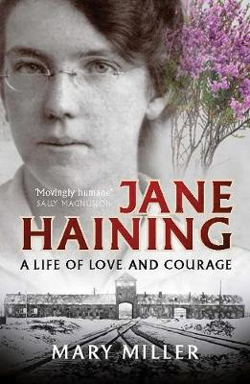
The theme for this session is “Heroes and Heroines?”. We will hear about a range of fascinating people whose lives and contribution to society were influenced by their beliefs.

Among others, we hope to learn about Jane Haining who was sent by the Church of Scotland to wartime Hungary, and gave her life protecting the Jewish girls in her care.
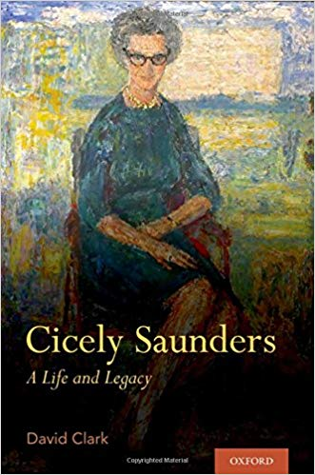

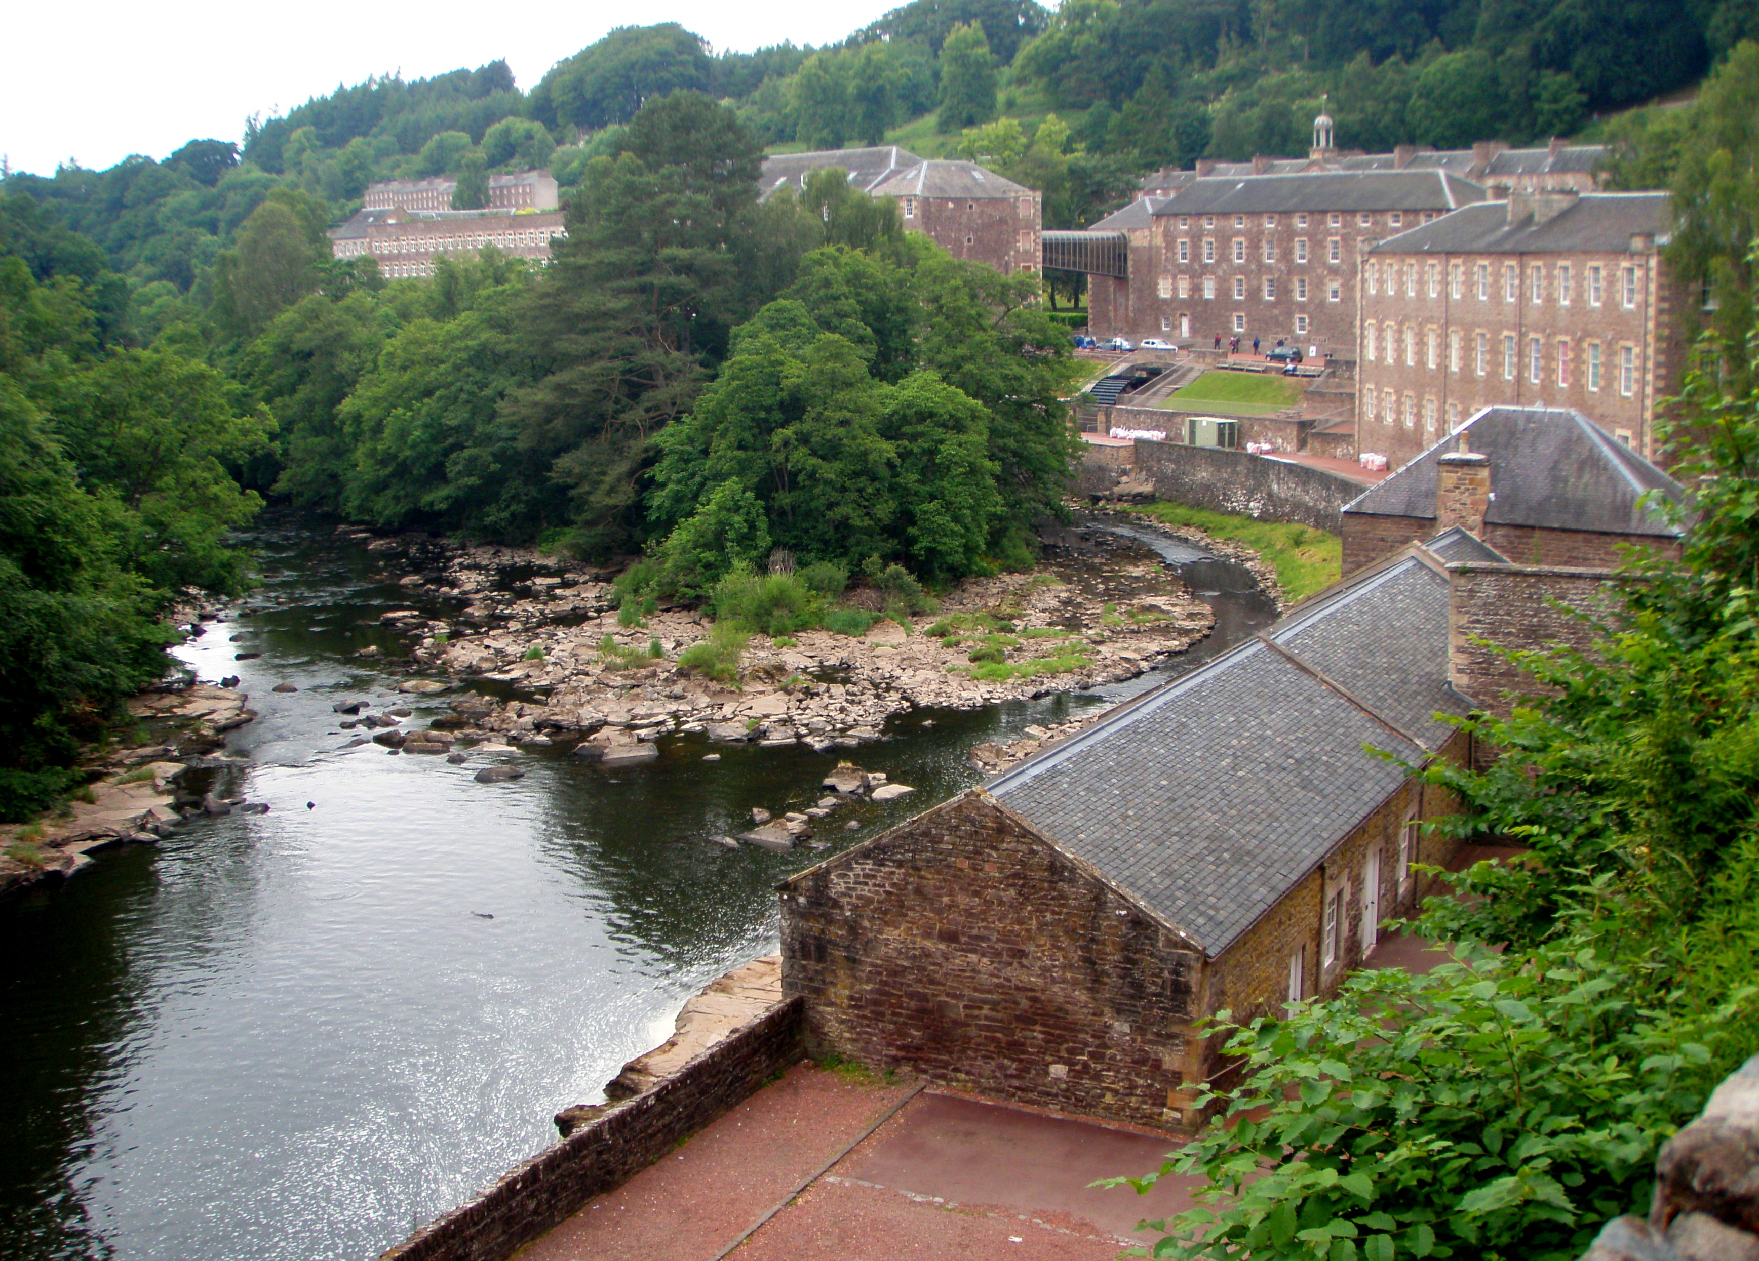
From the author of her biography we will learn about Cicely Saunders , who was the founder of the modern hospice movement.

Also a talk about Robert Owen, the 18th Century mill owner whose pioneering community at New Lanark revolutionized thinking about workers' lives.

More details will follow in due course and we hope to see you there.

Social Events September – December
September | Friday 13th at 7.30pm in the Fellowship Room  Film Night ‘The Book Thief’  Sunday 22nd at 7.30pm in the Sanctuary  Dessert Island Discs (£5.00)
October | Saturday 19th in the Church Hall  Murder Mystery High Tea. Tickets Approx £15 BOOK NOW  Friday 25th at 7.30pm in the Fellowship Room  Film Night ‘Sabrina”
November | Saturday 9th at 7.30pm in the Sanctuary  Orchardhill’s Top Ten – A musical evening revealing the all-time favourite pieces of music as voted by the Congregation  Wednesday 13th at 1.30pm-3.30pm in the Fellowship Room  Christmas Crafts  Friday 15th at 7.30 in the Fellowship Room  Film Night ‘The Finest”
December | Friday 6th at 7.30pm in the Church Hall  Orchardhill’s Annual Christmas Dinner – Cost to be confirmed. BOOK NOW  Friday 13th at 7.30pm in the Fellowship Room  Film Night ‘It’s a Wonderful Life’

Welcomers’ Rota
 | Entrance | Sanctuary | Greeters/Ushers
SEPTEMBER
1 | Irene Kinniburgh | Peter Worthington | Sandra Cherrie
8 | Shona Fletcher | Peter Worthington | Willie Hendry
15 | Willie Hendry | Dorothy Cartlidge | Shona Fletcher
22 | Jim Blair | Dorothy Cartlidge | Irene Kinniburgh
29 | Shona Cook | Susan McQuilter | Jim Blair
OCTOBER
6 | Anne Barr | Susan McQuilter | May Liddle
13 | Marion Watson | Alex Mall
20 | May Liddle | Alex Mall | Anne Barr
27 | Irene Kinniburgh | Dave Thomson | Nanette Davidson

Offering Teams
SEPTEMBER
1 | Peter Worthington, Valerie Clarke, Roseanne Henderson
8 | Peter Worthington, Valerie Clarke, Bruce Paterson
15 | Dorothy Cartlidge, David Howard, Bruce Paterson
22 | Dorothy Cartlidge, David Howard, Fiona Thomson
29 | Susan McQuilter, Hilary Kennedy, Fiona Thomson

OCTOBER
6 | Susan McQuilter, Joyce Winning
13 | Alex Mall, Joyce Winning
20 | Alex Mall, Anne Anderson , Irene Kinniburgh
27 | Dave Thomson, Anne Anderson, Irene Kinniburgh

Scripture Readers

SEPTEMBER
1 | Jim Blair
8 | Shona Fisher (communion)
15 | Lorna McLean
22 | Joyce Winning
29 | Lindsay Barr

OCTOBER
6 | Anne Anderson
13 | Garry Crosbie
20 | Fiona Thomson
27 | Donald Carmichael

Congregational Register

Deaths
Ian Ross |  | Passed away 05/07/19
Janet Livingston |  | Passed away 30/06/19

Orchardhill Calendar

September
Sunday | 1 | 10.30am | Family Worship | Rev Grant Barclay
Monday | 2 | 6.15pm | 2nd Brownies | Memorial Hall
 | 2 | 8.00pm | Crosswords | Fellowship / Session room
Tuesday | 3 | 6.00 pm | Soundwaves | Church Hall
 | 3 | 6.30 pm | Rainbows | Memorial Hall
Wednesday | 4 | 6.30 pm | 2nd A Brownies | Church Hall
 | 4 | 7.00 pm | Quiet Time | Sanctuary
 | 4 | 7.30 pm | 2nd A Guides | Church Hall
 | 4 | 7.30 pm | Choir | Session room
Thursday | 5 | 6.30pm | 8th Brownies | Church Hall
Friday | 6 | 6.30pm | Boys Brigade Anchor Boys and Junior Section | Memorial Hall
 | 6 | 7.30 pm | Company Section | Memorial Hall
Sunday | 8 | 10.30am | Family Worship | Rev Grant Barclay
Sunday | 15 | 10.30am | Family Worship and Sacrament of the Lord's supper | Rev Grant Barclay
Tuesday | 17 | 7.30pm | Kirk Session meeting | Session room
Sunday | 22 | 10.30am | Family Worship | Rev Grant Barclay
 | 22 | 7.30 pm | Dessert Island Discs | Sanctuary
Sunday | 29 | 10.30am | Family Worship | Rev Grant Barclay

Flower Delivery
If you can help with delivering the flowers after Church please add your details to the list at the Church door. If you would like further information please speak to Norma Hannah any Sunday or on 0141 638 7515.
Please also insert the September and October count rota as below {may not be exactly the same as what you have on the master copy}
Many thanks, Norma
1-Sep | Peter Worthington 638 4316 | Valerie Clarke 638 6148 | Roseanne Henderson 571 7375
8-Sep | Peter Worthington | Valerie Clarke | Bruce Paterson 571 7862
15-Sep | Dorothy Cartlidge 571 7839 | David Howard 571 7854 | Bruce Paterson
22-Sep | Dorothy Cartlidge | David Howard | Fiona Thomson 571 7153
29-Sep | Susan McQuilter 638 6936 | Hilary Kennedy 638 6114 | Fiona Thomson
6-Oct | Susan McQuilter | Norma Hannah 638 7515 | Joyce Winning 571 7617
13-Oct | Alex Mall 585 7169 | Norma Hannah | Joyce Winning
20-Oct | Alex Mall | Anne Anderson 563 2395 | Irene Kinniburgh 638 3722
27-Oct | Dave Thomson 638 3289 | Anne Anderson | Irene Kinniburgh

Orchardhill Parish Church, Church Road, Giffnock Glasgow G46 6JR
phone 0141 638 3604)
website: www.orchardhill.org.uk
email:secretary:Orchardhill.org.uk

Orchardhill Parish Church: Scottish Charity number SC 009774

