08
Fall
 | THE  RECORD  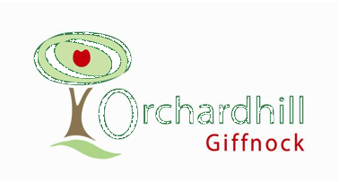

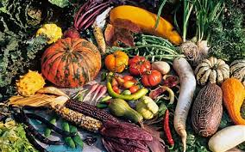
OCTOBER

2019

A Word from your Minister

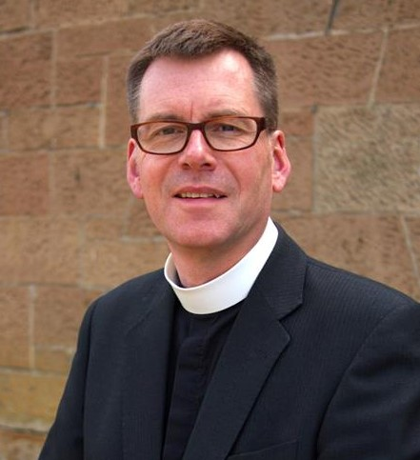

Harvest Lessons

This year, our harvest focus shall be slightly different. While we are already collecting a range of foodstuffs to support the Lodging House Mission Harvest Appeal as usual, we will concentrate on harvest and food in another way at our harvest service on the first Sunday in October.

We have purchased ninety kilograms of rice and wish to pass this on to you, with a specific request. First, though, the commercial break; this is not any rice, but Kilombero rice grown and harvested by hand in Malawi. It’s artisanal and has won a Great Taste award. Moreover, it is the most ethical rice on the market, according to Ethical Consumer magazine. It’s clearly something you’ll want to get your hands on.
Well, you can. We’re hoping you’ll take (or buy) a one kilogram bag and give us £5 for it. That’s a lot for a bag of rice that size, but just think what you’re getting for the money. You could even recoup the cash by cooking the rice and serving it at a meal for friends, for which you might charge them £1 per head – or more, if you think they’ll buy into the vision.

The money, you see, doesn’t simply pay for the rice. £450 is what it costs a farmer in Malawi to send a child to school for a year. If we purchase 90kg of rice at this unit cost, we will have helped one child to access education for one year. It is difficult to quantify the value of that learning over a lifetime, but it is certainly more than the money we are paying. We’re able to do this through a joint venture with Paisley-based charity the Balmore Trust. Already, over 800 schools and churches have taken on this challenge. That means a similar number of pupils to those attending Giffnock Primary have been helped to learn, as people have bought bags of rice.

This harvest, as ever, we look back with gratitude and thanksgiving on what we have received. Equally, we look forward as we contribute in a small, achievable and fun way, to increase learning and opportunity in a challenged part of the world. A harvest lesson for us leading to lessons there which will, in time, produce an even greater harvest.

I hope you’ll be involved.

Your Minister
Grant Barclay.

On the Cover

Leviticus 23:22

“When you reap the harvest of your land, do not reap to the very edges of your field or gather the gleanings of your harvest. Leave them for the poor and for the foreigner residing among you. I am the Lord your God.”

“Don't judge each day by the harvest you reap but by the seeds that you plant.”
Robert Louis Stevenson

Orchardhill’s Sunflower Spectacular

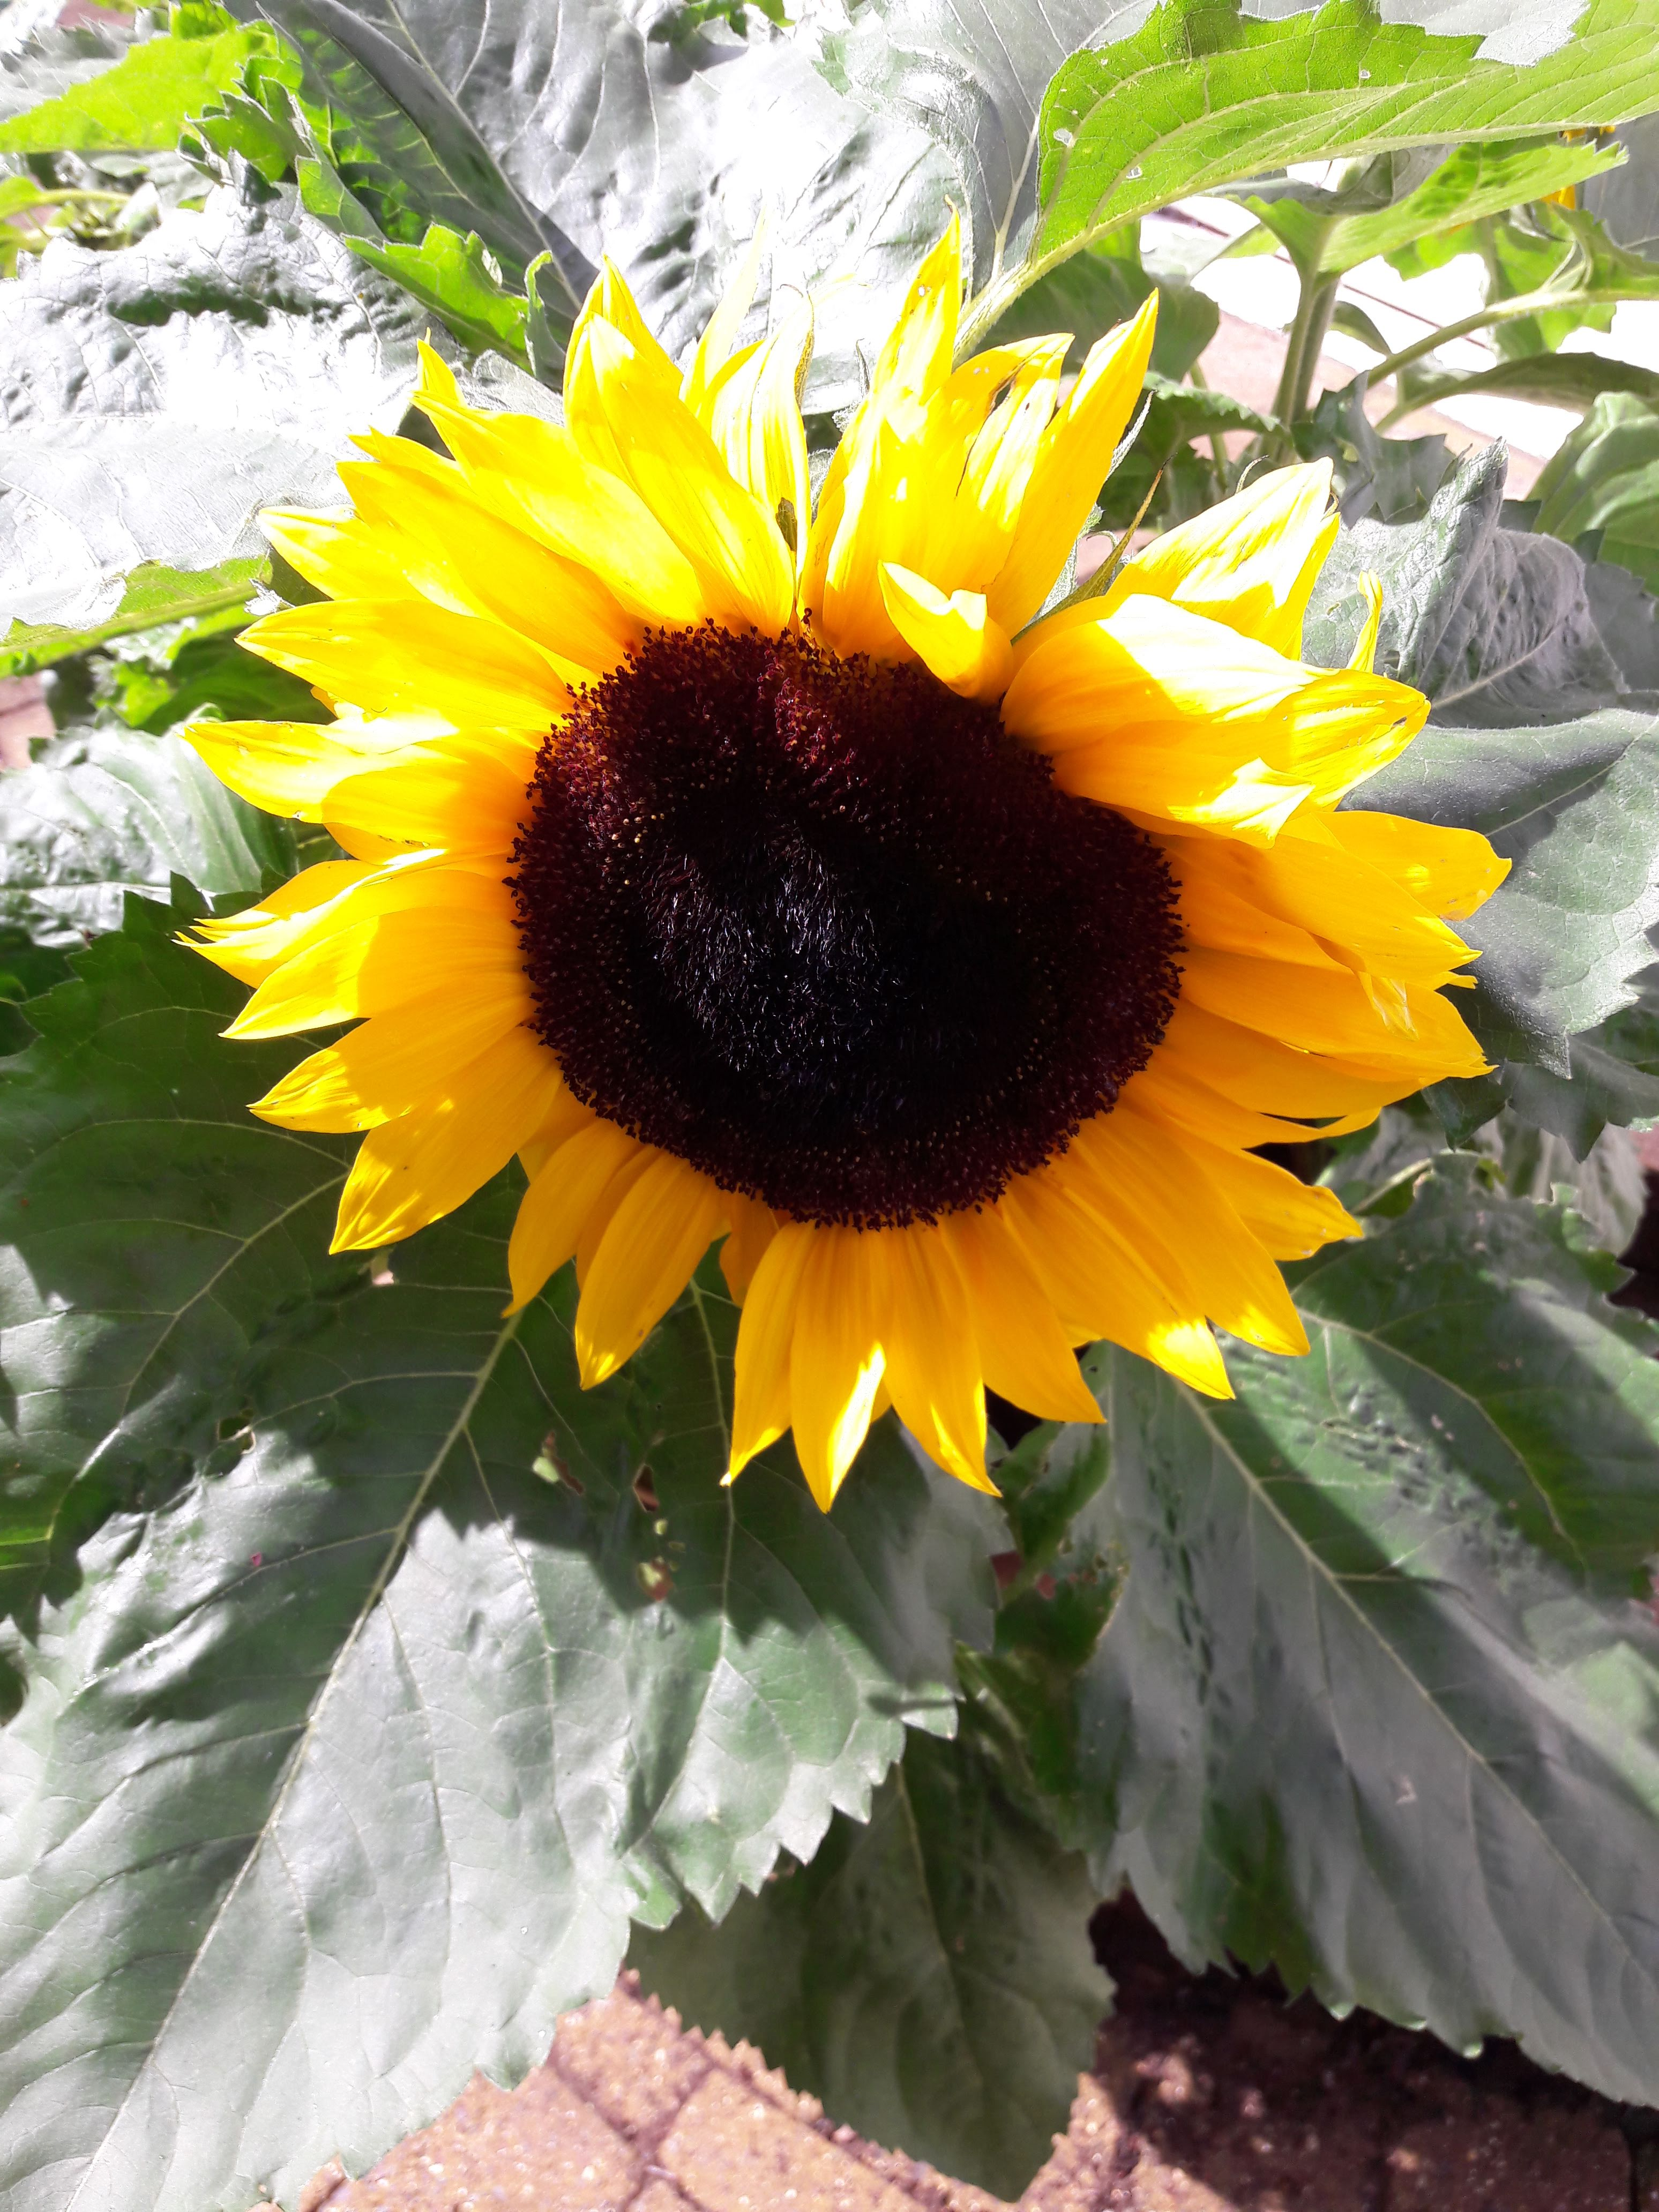
PLEASE SAVE THE DATE - SATURDAY 29 AUGUST 2020

The following events will take place

- Sunflower installation around the church and memorial hall
- Sunflower growing competition
- Sunflower art exhibition
- Afternoon tea; prize giving; stalls.

The Orchard Community Café

During the October school holiday the Café will open on Tuesday 15th October from 10am till 12noon for tea, coffee and cakes.

The Guild
We look forward to seeing friends old and new again in October. We’re few in number but we are enthusiastic and friendly, and we hope that our varied syllabus (see page 10 for syllabus) will be of interest to everyone.
Please come along and enjoy a relaxing afternoon. Can members please note that the capitation fee is now £12.

The Messiah by Handel

Most people will at least have heard of this great oratorio, but have you ever been to a live performance of it? One such performance was being given in Lockerbie Town Hall many years ago, and old Jimmy Scott from Dumfries thought he might like to go. He tried to persuade his wife to go with him, but she wasn’t too keen.
‘Naw Jimmy, ye ken fine it’s no in ma line. Gie me a bit o’ comedy, or a singsong at the Hall; naw, you go yersel’ and tell me aboot it when ye come hame’.
So Jimmy went on his own. He had no idea what to expect. In fact, he had never heard of ‘The Messiah’; it was just that he fancied doing something a bit different from his usual Saturday night visit to the Globe Inn.
When he came home. Jimmy’s wife was all ears. ‘Come on then, tell me aboot it’.
‘Weel’, said Jimmy, ‘it wis all right, but no’ quite what I expected. There wisnae a lot o’ movement on the stage. In fact, there wisnae a lot o’ room on the stage. It wis fu’ o’ singers. Ah’d been sittin’ a bit, when in comes a load o’ fellas, carrying fiddles. Then they brought in the biggest fiddle ah’d ever seen. It wis so big, they had to wheel it in on castors, an’ a wee fella rubbed its belly wi’ a stick, an’ you should huv heard it groan. It sounded like a sow wi’ croup. Well, aw the fiddles joined in an’ made such a racket. Then they settled doon an’ it all went quiet. After aboot a minute, in comes the Messiah; well, ah think it wis him, because everybody clapped, an aw the fiddlers stood up to welcome him. He wis a dapper bloke, all dolled up in a white westcoat wi’ a red carnation in his buttonhole. Ah’m sure he must’ve been the Messiah. Then he picked up a little stick an’ started wavin’ it at everyone on the stage. They were all starin’ at him, wonderin’ whit he wis up tae. Then they started to sing.
They’d no’ been going long before they were screetchin’ like cats. They wanted to know ‘who were the King o’ Glory’. First one side said ‘He is the king o’ glory and then the other side ‘He’s the king o’ glory’, and then they went at it hammer and tongs, but it fizzled out in the end. Then there wis a right to-do aboot some sheep that had gone astray. Some o’ the singers must a’ bin partial to a bit o’ mutton, ‘cos they kept singing ‘A’ wee like sheep’. Well, ah think the lost sheep must’ve belonged to one o’ the singers, because he stood up an’ sed ‘ev’ry mountain and hill should be laid low’. ‘Good’, ah though tae masel’, ‘if they flatten aw the mountains, they’ll be sure tae find them sheep that have gone astray.’ Then the organist started up an’ the band joined in, and by jings, they seemed to be getting’ mad wae summhin’. The way they were sawin’ at their fiddles, ah wis expectin’ em tae fa’ apairt.
Then after that a’ the wimen stood up to sing. Believe me, some o’ them were a bit past it. By the looks o’ them they must huv been 70 if they were a day, an’ they sang ‘unto us a child is born ‘an a’ the fellas shouted wonderful’. Ah thocht ‘it wis a bloomin’ miracle!’ Then they all composed theirsel’s a bit, and sang aboot a wumin called Joyce Greatly. Ah’d never heard o’ her, but apparently she’s a daughter of Zion, whoever he is.
Ah wis getting’ a bit fed up by now. Ah’d bin sittin’ for nearly two hours, when all of a sudden, ah got cramp in me leg. Ah jumped oot o’ ma seat, an’ dye know? Everybody else jumped up at the same time. They must huv had cramp as well. Then the choir shouted ‘it’s going’ tae rain for ever an’ ever’. Well, ah never thocht tae bring ma brolly, so ah thocht ah’d best get aff hame before it started. So, seein’ as how ah wis on me feet ah reckon ah’d had ma money’s worth. Ony road it wis a good do, and ah hope they find them lost sheep.

Bridges - A Strong Connection
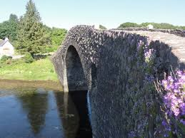
The Clachan Bridge

We are very fortunate in Scotland to have many fine bridges throughout our magnificent land. The Clachan Bridge on the Isle of Seil is especially beautiful in early summer when it is covered in purple fairy foxgloves. Then there is the Brig O’Doon in Alloway made famous in Robert Burns’ poem “Tam O’Shanter”. Nearer to home is the Clyde Arc or ‘Squinty Bridge’ in Glasgow which is part of the huge regeneration of the Clyde Waterfront. Over in the East there is the iconic Forth Rail Bridge, famous in the past for being repainted continuously to maintain its integrity. Fame also attaches to the Glenfinnan Viaduct which features on £5 notes and is featured in Harry Potter and the Chamber of Secrets. Finally, there is the Kylesku Bridge which crosses Loch a’Chàirn Bhàin and connects Skye and mainland Scotland.
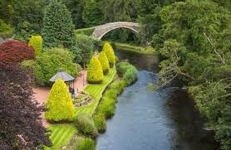
Brig o'Doon

Whilst bridges may differ in appearance and construction, they all in essence serve the same purpose- to create a connection between one thing and another.
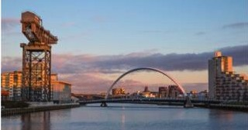
The Clyde Arc

We have our own “Bridges” here at Orchardhill of course - the group of teenagers who meet during the church service on a Sunday is a stepping-stone between the younger children and the adult congregation.
Just like its brick, masonry, concrete or steel counterparts, Bridges is so much more than it appears. On closer examination, it is a group of brilliant teenagers who provide each other with love, care and support and who give hope for an exciting future for our church.

Forth Rail Bridge

The two things a bridge links should both flourish because of the existence of it. Our congregation and our youth are connected and each has something to contribute to the other, an inter-generational connection. It is, of course, vitally important that the connection, the bridge, is maintained continuously just like the Forth Bridge but with love, care and support rather than paint.

Glenfinnan Viaduct

Our young folk welcome this greater connection and love to share their own take on important matters. Bridges will be leading worship one Sunday in October and hopes that this will be an enriching experience for everyone.

Kylesku Bridge
The youngsters continue to help our organisations on a weekly basis and support each other when they get together on a Sunday. There is an open invitation to all within the congregation to join them and share time together to help the connection grow and become stronger. Getting to know each other and supporting each other can only strengthen our particular bridge and improve the connections for all of us.

The Choir
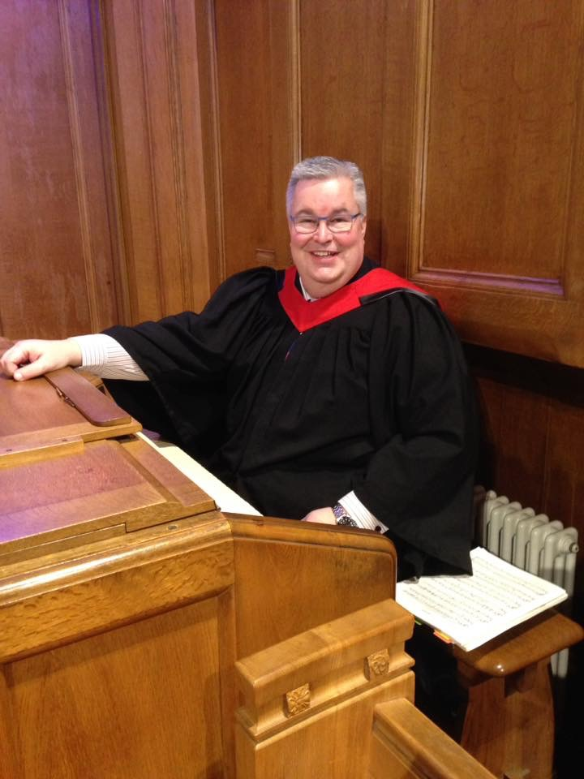
When: Wednesday evenings at 7.30pm - we run from September to May - our practice time is 1.5hrs weekly

Where: The Session Room

We are a friendly and welcoming group of people that enjoy singing, using our talents to lead worship and present anthems, introits and musical cantatas.

Our last session saw us lead an evening Remembrance Service in November, Nine Carols & Lessons leading up to Christmas, an Easter Cantata and an evening of music to close our year.
Our rehearsals are fun and good humoured but we get through a lot of music. The Choir rise to any challenge I set them and there are some tricky harmonies to perfect.
We also hold social evenings where we can relax and enjoy each other’s company usually accompanied by good food and refreshments!
I became Organist and ChoirMaster at Orchardhill in November 2006 and since then the Choir and I have worked on repertoire as diverse as:
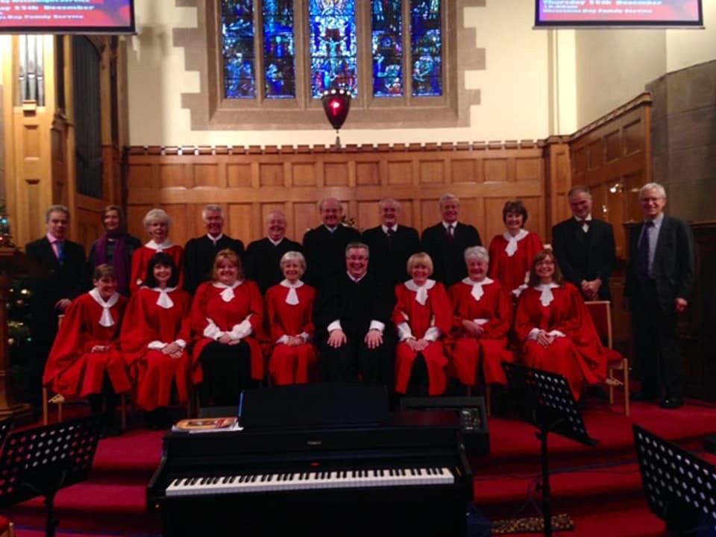
The Holy City;
Benedictus from The Armed Man;
You Raise Me Up;
O Holy Night;
You ain’t got that thing if you ain’t got that swing!
The Ashokan Farewell.

We have held Songs of Praise where I invite professional musician friends to accompany us and we have sung an Easter Cantata accompanied by a string quartet.
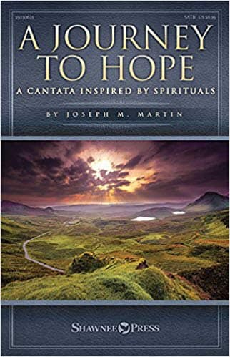
We have also rehearsed and presented eight new Christmas along with four new Easter Cantatas. We really enjoy the works of American composer Joseph M Martin who manages to mix traditional melodies with modern music.

We are very fortunate to call upon friends of the Choir to join us for our events. They have become stalwarts and they enjoy themselves as much as we enjoy having them.
For our 2019/2020 session we shall be working on anthems for Harvest and Remembrance and Nine Carols & Lessons for Christmas. Plans for Easter include another new Cantata and an evening of music to close our session in the form of Songs of Praise.

If you would like to join us you would be most welcome. You don’t have to be able to read music just a desire to praise God in sung worship and have a good sense of humour!

David Fisher

The Generation Story


Our intergenerational project with Giffnock Nursery and Primary School has restarted after the summer break and this term the school group will engage with us on Tuesdays and the Nursery will be on a Thursday. The school group will continue to help develop the living museum in the Tower room and the school's history and the nursery group will continue to share songs and activities together. The Head Teacher has sent a letter out to parents asking them to contribute memories/items for the Schoolroom Museum in the tower.

Gardening: We’re hoping that the school gardening group and our church gardeners could develop a community garden in church grounds and so we hope to invite our families to come on a Saturday morning to get this started.
The class teachers have asked for help from us for some of their topic work this term: -
- P7 would like people who either lived through WW2 or have stories passed down to them from parents who fought in the war
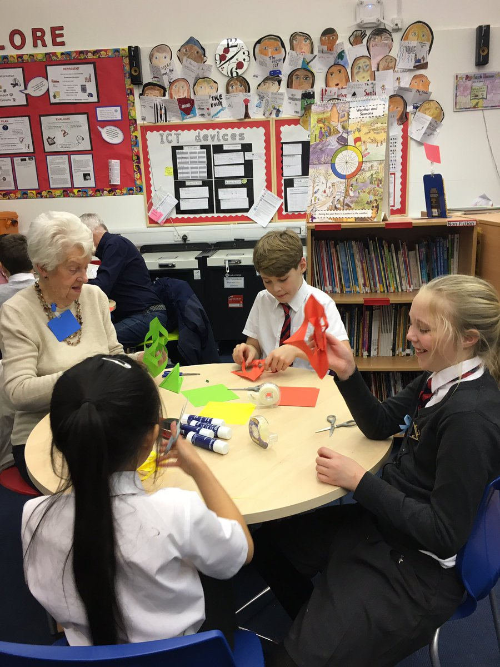
- P4 would welcome visitors for Scottish history stories
- P3 would welcome visitors with local history knowledge
- P1 would welcome experienced helper or two to join class for basic crafts or stories
- P2 & P3 would love to have sewing helpers from 1:30pm – 2:45pm

The school will have a stall at Orchardhill’s Christmas Fair on Saturday 23 November and they have invited us to have a stall at the Parent Council Christmas Fair on Saturday 30 November We are also hoping that the school will be involved with the Tree of Kindness this Christmas.
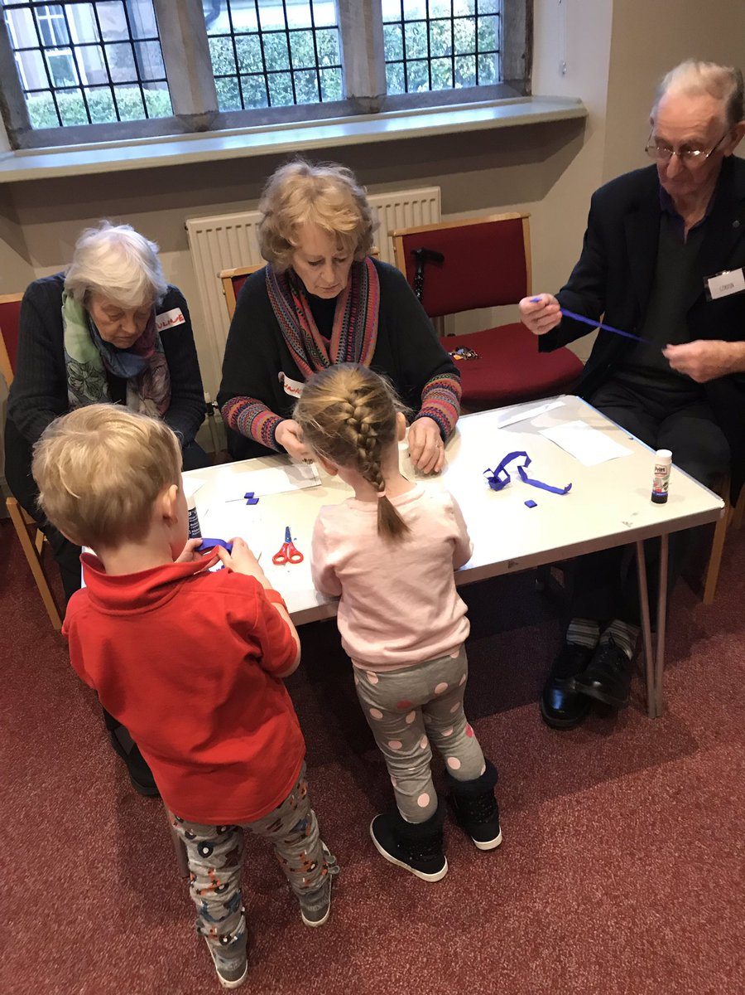

Our intergenerational activities are social engagements and interactions, bringing together younger and older generations for a common purpose. They build on the strengths that different generations have to offer, nurture understanding and mutual respect, and challenge ageism. Both parties have the opportunity to give as well as receive, and to feel a sense of ownership and achievement. Most of all it puts a smile on everyone’s face, and so if you can spare an hour or two to get involved and share your time, skills and experience with the children and your community, then please let the Church Office know (638 3604) or email: generationstory@orchardhill.org.uk

Lindsay Barr

East Renfrewshire Good Causes

Orchardhill Contributions to ERGC Since April 2019

Situation: This gentleman has extensive physical disability due to lifelong cerebral palsy; Progressed to the extent that client has marked muscle stiffness and joint problems, and now client is reliant on tracking hoist and carers to transfer and have any form of mobility.
Orchardhill provided £175, which helped toward a period of specialist neurological physiotherapy provided by the Bobath centre (specialists in treating all severity of cerebral palsy) in Glasgow.
Situation: Young woman fleeing domestic abuse has no TV and no means to buy one.
Orchardhill provided £20 to buy a TV via Helping Hands
Situation: A woman who has had serious issues, is now trying to get her life back on track. She has her son now back living with her but unfortunately there is no bedroom furniture in the house.
Orchardhill contributed £30 towards bedroom furniture via Helping Hands
Situation: A mother has a son with autism, and his family have a number of other problems. Mum contacted the East Renfrewshire Social Work department as she felt that she was having problems coping with having an autistic teenager.
Orchardhill contributed £260 towards helping with activities for the son.
Situation: an inpatient who has been in Leverndale Hospital for the past few years. He has a diagnosis of schizophrenia and his mental illness is resistant to treatment with medication.
Orchardhill contributed £114 (as did another charity) towards the cost of a laptop for him to listen to music etc.
Situation: A young mother fleeing domestic abuse in Glasgow now lives in Barrhead. She has a one year old girl and delivered a baby boy two weeks early in June 2019.
Orchardhill contributed £115 to supply items for the new baby.

Life & Work Renewal

The order for Life &Work for 2020 is now due to be sent to Edinburgh for renewal.
However, please note that your annual subscription is NOT due for payment until 26th January 2020 and that despite increased postage and production costs the price for the magazine will remain at £2.80 per copy.

If you wish to change / cancel your order could you please telephone Jim or Aileen Blair on 638 1901 by Sunday 25th October at the latest.

Thinking Allowed 24th October

Speaker: Mary Miller "Jane Haining : A Life of Love and Courage"
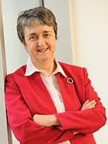
Mary Miller

Jane Haining was one of Scotland's heroines. A farmer's daughter from Galloway, Jane went to work at the Scottish Jewish Mission School in Budapest in 1932, where she was a boarding school matron in charge of around 50 girls, most of them Jewish. She refused to leave Hungary in 1940, and in March 1944 when Hungary was invaded by the Nazis, she remained with her pupils.
Mary Miller was a founder member and Director of the Jeely Piece Club, sharing with local families in establishing self-help and support for parents and children in a Glasgow housing scheme. Later specialising in the care of traumatised children, she carried out a similar role for HIV+ orphans in rural Zimbabwe from 2007-2012. Named Evening Times ‘International Scotswoman of the Year’ in 2009.
Venue: Orchardhill Church 7.30 pm for 8.00 pm on Thursday 24th October 2019

Who’s Who In Our Church

Margo Ritchie (76) worked as a clerkess for many years. Living in Airdale Avenue, originally Margo went to the Congregational church with her husband, and when the children David, Derek and Lynda came along, their friends were at Orchardhill Sunday School, so Margo lifted her lines and joined us approximately 48 years ago while the Rev. J Speirs was preaching.
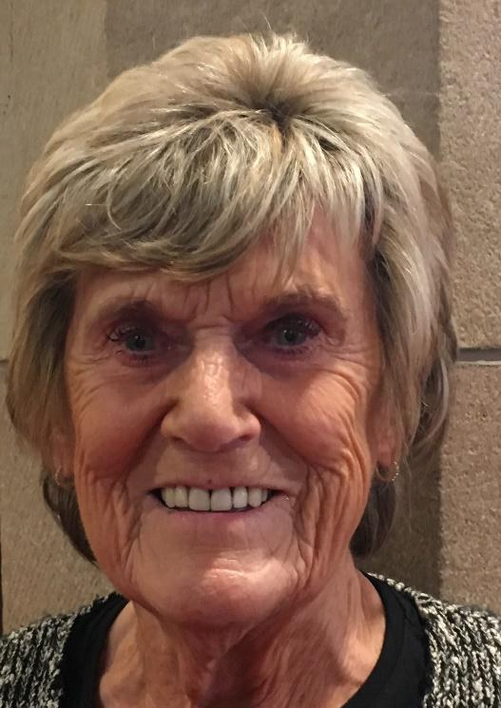
The boys were in the Boys’ Brigade at The Park Church as Orchardhill didn’t have a B.B in those days, and Lynda went through the Brownies and Guides in our church.
Margo says she enjoys looking at the main chancel window - it is her favourite feature in the Church.
After losing her husband, Margo felt she needed to get out into the community and help, and she then joined the Orchardhill Community Café which she enjoys coming along to; and giving of her time.
Margo is a quiet person, but when asked every time to volunteer for anything, she is there with a smile on her face and sleeves rolled up ready to help.

Orchardhill’s Top Ten

It’s not too late to vote for your favourite piece of music for the Orchardhill Top Ten. You can vote on the church website or send an email to topten@orchardhill.org.uk Then come along to our fun evening on the 9th November and find out if your favourite made the most popular pieces of music in Orchardhill.

Guild Syllabus 2019-2020
Guild Theme: “Companions on the Road”

The Guild meets on Monday afternoons at 2pm in the Fellowship Room.
2019
Mon 7th Oct (2pm) “Venice” – Mr David Walker
Mon 21st Oct (2pm) Guild Theme: “Companions on the Road” – Rev. Grant Barclay
Mon 4th Nov (2pm) “Hi-Lites” – Houston Choir
Mon 18th Nov (2pm) “Royal Security” – Mr Ian Thomson
Mon 9th Dec (2pm) Christmas Lunch – Dalmeny Park Hotel

2020
Mon 27th Jan (2pm) “Beadle – Undertaker – Celebrant” – Marion Macdonald
Mon 10th Feb (2pm) Guild Project - “The Sailors’ Society – a chaplain for our ports” – Rev. Rebecca Haldane
Mon 24th Feb (2pm) Mr Archie Hunter
Mon 9th March (2pm) “Castlemilk House and the Stirling-Stuart Family” – Mr Iain Lowdon
Mon 23rd March (2pm) Musical Bingo

Deadline for November’s Orchardhill Record
Sunday 13th OCTOBER is the deadline for the November edition of the Orchardhill Record.
Contributions should be sent by email to Record-Team@Orchardhill.org.uk before 1.00pm or left in the relevant slot in the rack in the church corridor no later than 10.30am. Using that email address ensures that every contribution goes to the editorial team not just the editor.
We prefer contributions to be sent by email, and we cannot accept any handwritten or typed item that does not identify the source. Nor can we accept pdf files. A photograph or logo must not be embedded in the article. Please send photos and the like as separate attachments to allow flexibility in laying out pages.
You are required to ensure anyone featured in your article(s) has given consent to be identified either for the specific article, club, group or more generally for Orchardhill Record.
The editor acknowledges every contribution. Contact them before the deadline if you have not received confirmation of your contribution.

Welcomers
 | Entrance | Sanctuary | Greeters/Ushers

OCTOBER
6 | Anne Barr | Susan McQuilter | May Liddle
13 | Marion Watson | Alex Mall
20 | May Liddle | Alex Mall | Anne Barr
27 | Irene Kinniburgh | Dave Thomson | Nanette Davidson

NOVEMBER
3 | Jo Weir | Dave Thomson | Irene Kinniburgh
10 | Evelyn Borland | Dave Thomson | Isabel Vance
17 | Shona Cook | Dave Thomson | Evelyn Borland
24 | Anne Barr | Norma Hannah | Willie Hendry

Offering Teams

OCTOBER
6 | Susan McQuilter, Norma Hannah, Joyce Winning
13 | Alex Mall, Norma Hannah, Joyce Winning
20 | Alex Mall, Anne Anderson , Irene Kinniburgh
27 | Dave Thomson, Anne Anderson, Irene Kinniburgh

November
3 | Susan McQuilter, Joyce Winning
10 | Alex Mall, Joyce Winning
17 | Alex Mall , Anne Anderson , Irene Kinniburgh
24 | Dave Thomson , Anne Anderson , Irene Kinniburgh

Scripture Readers

OCTOBER
6 | Anne Anderson
13 | Garry Crosbie
20 | Fiona Thomson
27 | Donald Carmichael

November
3 | Shona Cook
10 | Ian Cartlidge
17 | Margaret Howard
24 | Willie Hendry

Congregational Register
Death: Well done thou good and faithful servant. Rest safe in the Lord.
On 14 September - Anna Blair
A full Tribute to Anna’s long and committed Christian life will appear in next month’s Record.

Life and Work
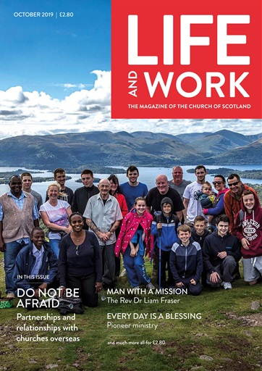
October 2019
IN THIS ISSUE
DO NOT BE AFRAID
Partnerships and relationships with churches overseas
MAN WITH A MISSION
The Rev Dr Liam Fraser
EVERY DAY IS A BLESSING
Pioneer ministry
and much more...

Social Events October – December
October | Saturday 19th at about 6pm in the Church Hall  Murder Mystery High Tea. Approx. £15 BOOK NOW  Friday 25th at 7.30pm in the Fellowship Room  Film Night ‘Sabrina”
November | Saturday 9th at 7.30pm in the Sanctuary  Orchardhill’s Top Ten – A musical evening  Wednesday 13th at 1.30pm-3.30pm in the Fellowship Room  Christmas Crafts  Friday 15th at 7.30 in the Fellowship Room  Film Night ‘The Finest”
December | Friday 6th at 7.30pm in the Church Hall  Orchardhill’s Christmas Dinner BOOK NOW  Friday 13th at 7.30pm in the Fellowship Room  Film Night ‘It’s a Wonderful Life’

Christmas Events

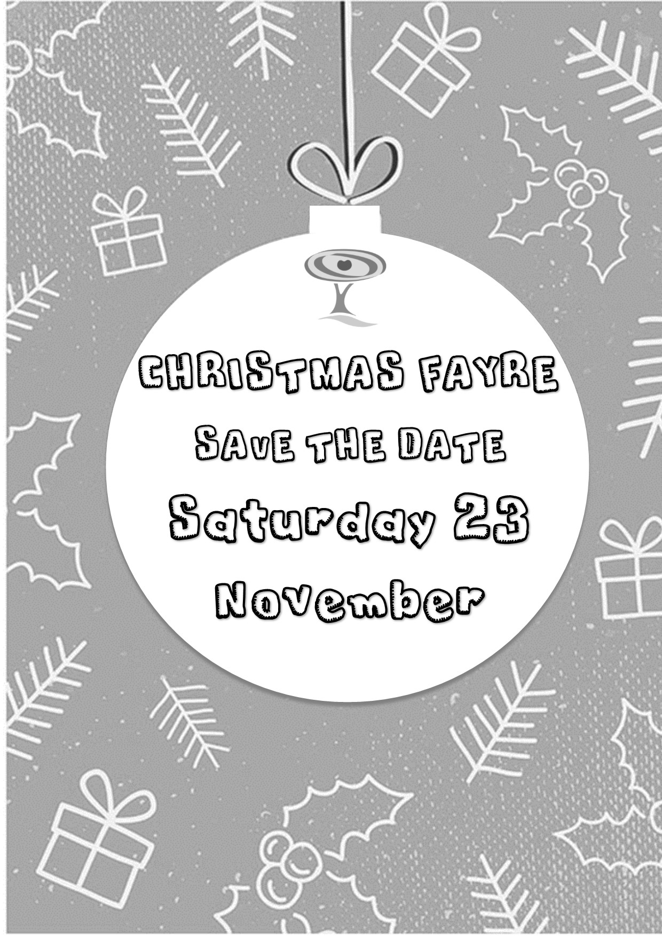

Annual Christmas Dinner Friday 6th December At 7.30pm
It is hoped that this event will be the first of what will become an annual event. Outside caterers will be used for this evening and so it is essential that we know who is coming AS SOON AS POSSIBLE.
What better place to celebrate the festive season than church amongst friends? In addition to the delicious food, there will be a few surprises to ensure the evening goes off with a bang. The tickets will be available very soon and the price will be confirmed then. It will be a BYOB event.
Let’s make this a really special event with a really good turn out. Plan now before diaries get full with other events.

A Wee Chuckle- Fun Time!
“Good morning!
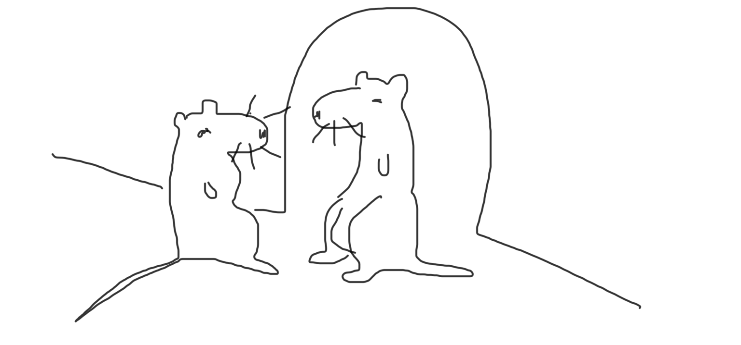
Do you have the love of cheeses in your life?”

(The following have appeared in church bulletins or actually been announced at church services- thanks to Max Bowen)

- Don’t let worry kill you off- let the Church help you.
- For those of you who have children and don’t know it, we have a nursery downstairs.
- The Rector will preach his farewell message, after which the choir will sing “Break Forth Unto Joy”.

YOU MUST BE JOKING.

Q: Who was the smallest person in the Bible? | A: Knee High Miah!
Q: What kind of man was Boaz before he got married? | A: Ruth-less!
Q: Did Eve ever have a date with Adam? | A: No, just an apple!

Puzzle Time

Let’s find out what this is a picture of. Hand in your answer at the Church office or submit it by email to Record-Team@Orchardhill.org.uk
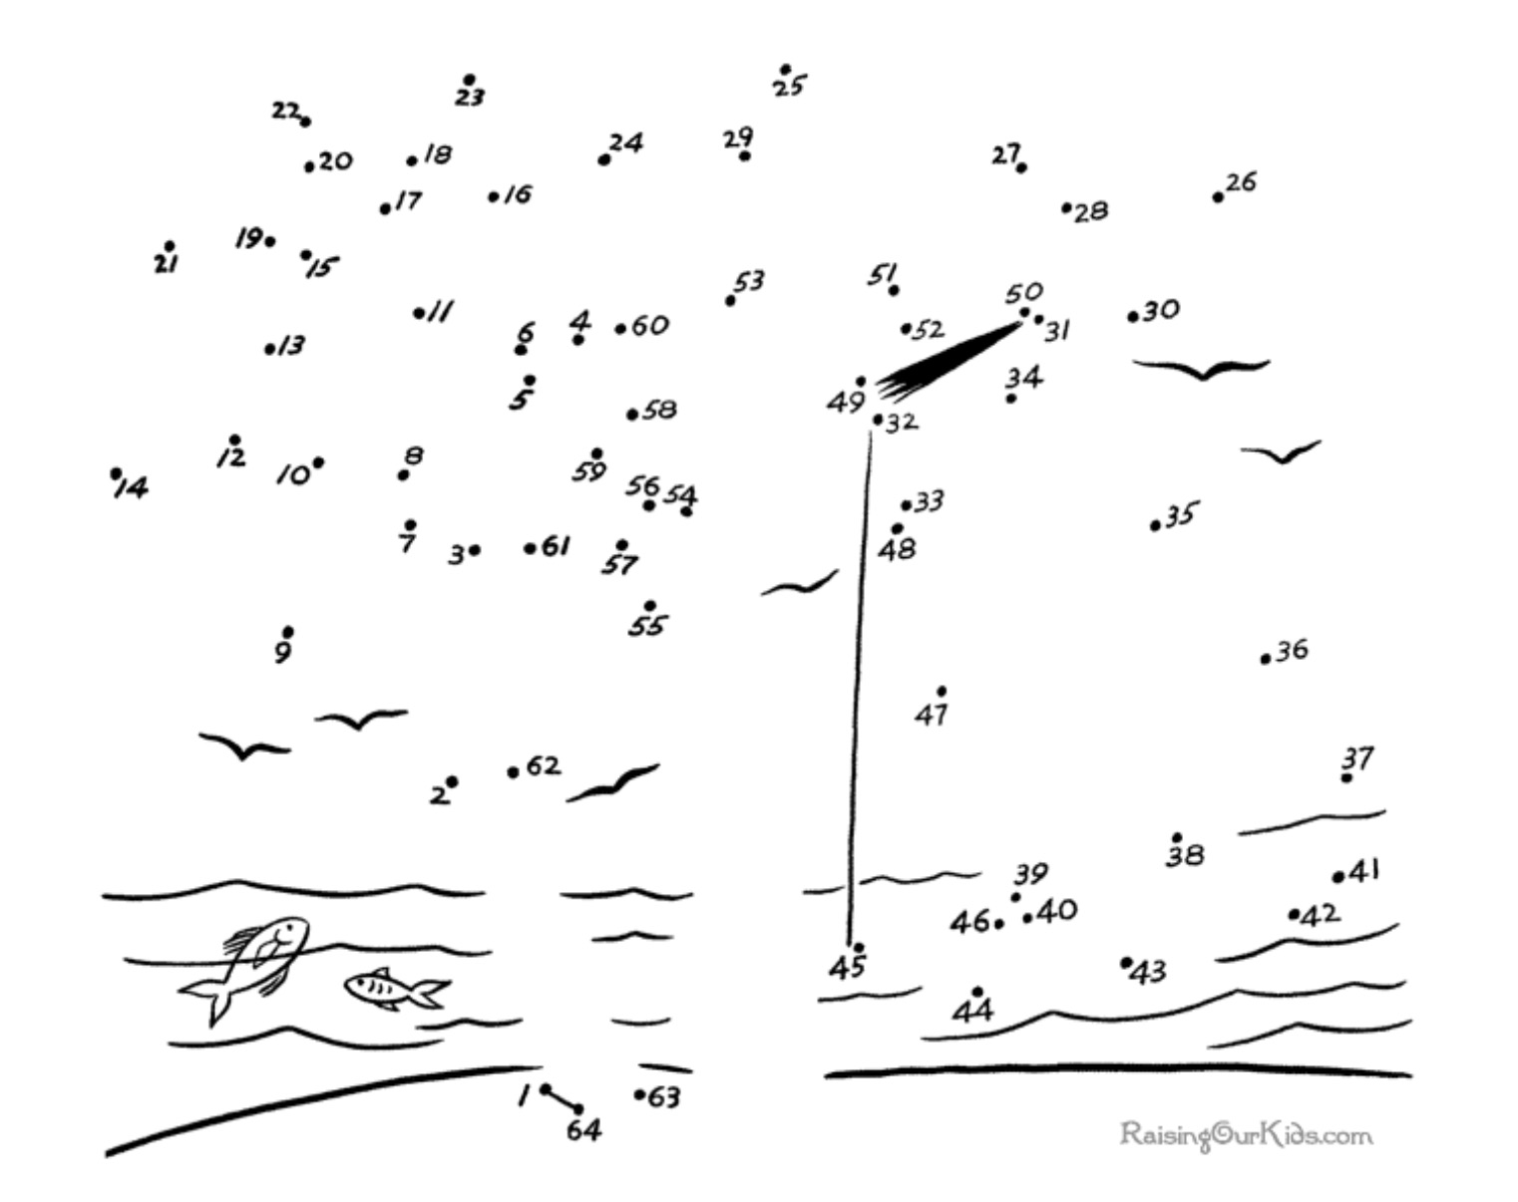

Answers to September Quiz
Answer 1. Judea
Answer 2. Martyrium (St Philip Martyrium)
Answer 3. Timothy
Answer 4. Theocrat

October Quiz
Can you give the more familiar names for the following places of worship?

Question 1. Collegiate Church of Saint Peter (A Royal Peculiar)
Question 2. St Peter’s Cathedral (Famous for its Rose Window)
Question 3. Cathedral of Saint John the Baptist (A famous piece of cloth is kept here)
Question 4. St Kentigern’s Cathedral (A survivor of the 1560 Reformation)

Entries should be sent either by placing answers in the quiz box at the tower door or by direct email to the record-team@orchardhill.org.uk

Orchardhill Calendar

OCTOBER
Tuesday | 1 | 10.00am | Orchard Café | Church Hall
Tuesday | 1 | 5.00pm | Creative Conversations | Lounge
Thursday | 3 | 10.00am | Orchard Café | Session Room
Sunday | 6 | 10.30am | Harvest Sunday | Rev Grant Barclay
Tuesday | 8 | 10.00am | Orchard Café | Church Hall
Tuesday | 8 | 5.00pm | Creative Conversations | Lounge
Wednesday | 9 | 1.15pm | Giffnock Primary School Inclusion Service
Thursday | 10 | 10.00am | Orchard Café | Session Room
Sunday | 13 |  | Family Worship | Rev Grant Barclay
Monday | 14 | 10.00am-4.00pm | Creative Workshop, Christmas Tales | Memorial Hall
Tuesday | 15 | 10.00am | Orchard Café | Session Room
Sunday | 20 | 10.30am | Family Worship | Rev Grant Barclay
Tuesday | 22 | 10.30am | Orchard Café | Church Hall
Tuesday | 22 | 7.30pm | Congregational Board
Thursday | 24 | 10.30am | Orchard Café | Session Room
Thursday | 24 | 7.30pm | Thinking Allowed | Session Room
Sunday | 27 | 10.30am | Family Worship | Rev Grant Barclay
Tuesday | 29 | 10.30am | Orchard Café | Church Hall
November
Sunday | 3 | 10.30am | Family Worship

Orchardhill Parish Church, Church Road, Giffnock Glasgow G46 6JR
phone 0141 638 3604
website: www.orchardhill.org.uk
email: secretary@orchardhill.org.uk

Orchardhill Parish Church: Scottish Charity number SC 009774

