I Know Church for Congregational Board Members.
The I know church administration system is shortly going to be available to Congregational Board members
Over the coming days you will be sent details of how to log on to the I know church admin system.
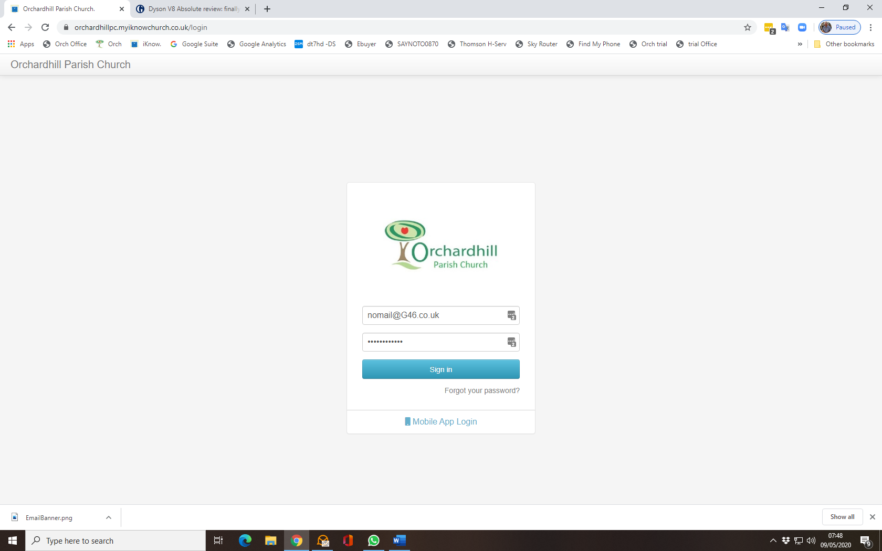

Follow the log in instructions
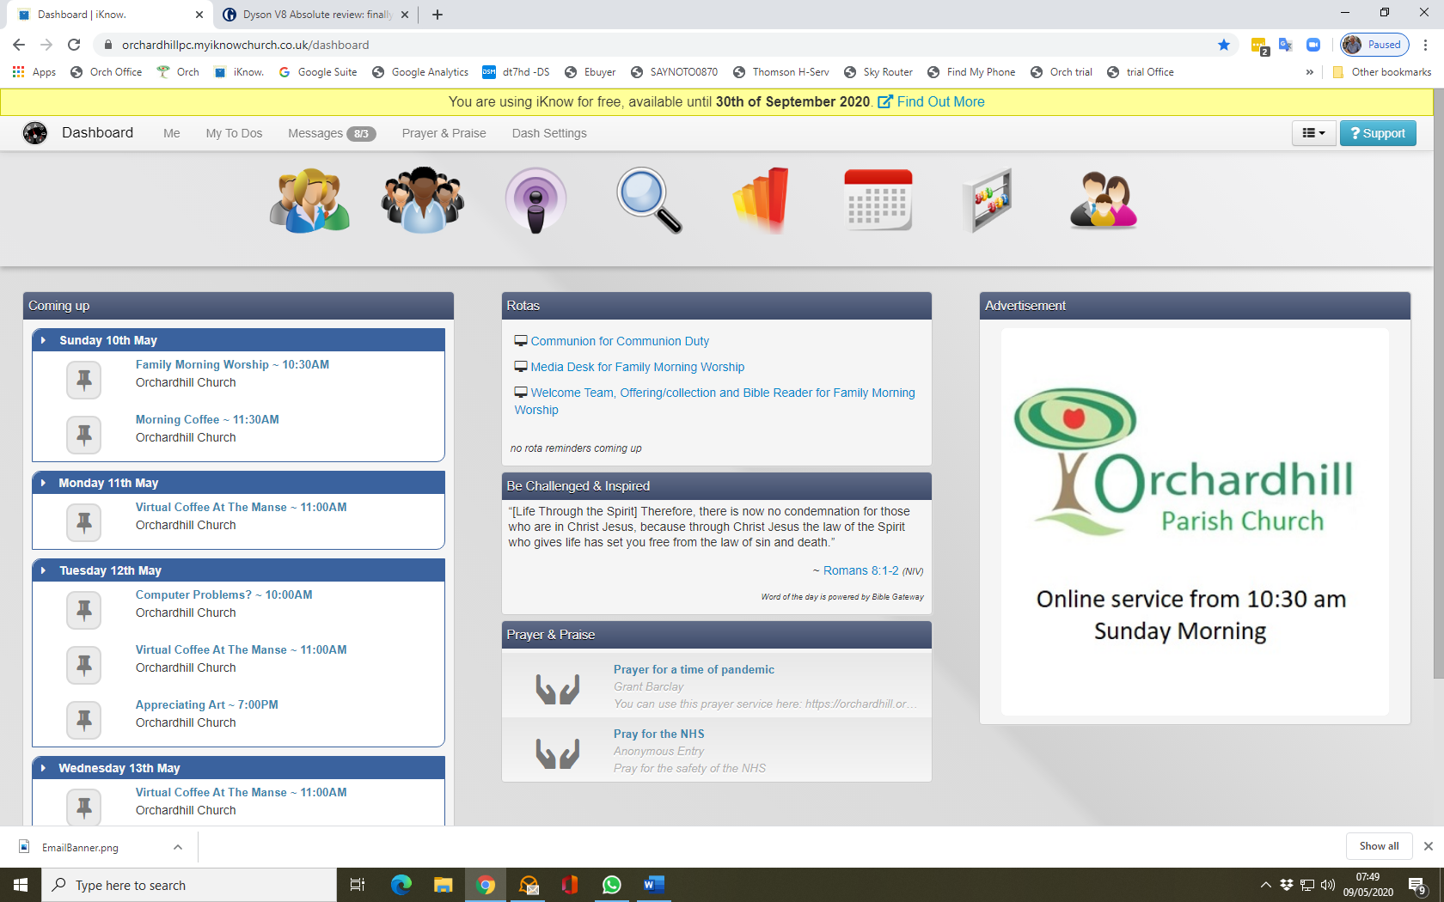
On the page above you will see the icon bar with all the functions available to you. Above the icon bar on the left hand side you will see the word dashboard next to that is the word “ME” click on this icon to check your personal information and update as required. On the right hand side of this page you will see that you can add times when you are not available for rota duties. By entering dates here, you will not be asked to do any rotas on those dates. You can also change your password and add a nice photo of yourself.
Once you have made your adjustments you must click save at the bottom of the page. Once saved you can leave this page by either closing the tab on your browser or on the dashboard row click on the small icon (speedometer head) next to dashboard to take you back to the dashboard.
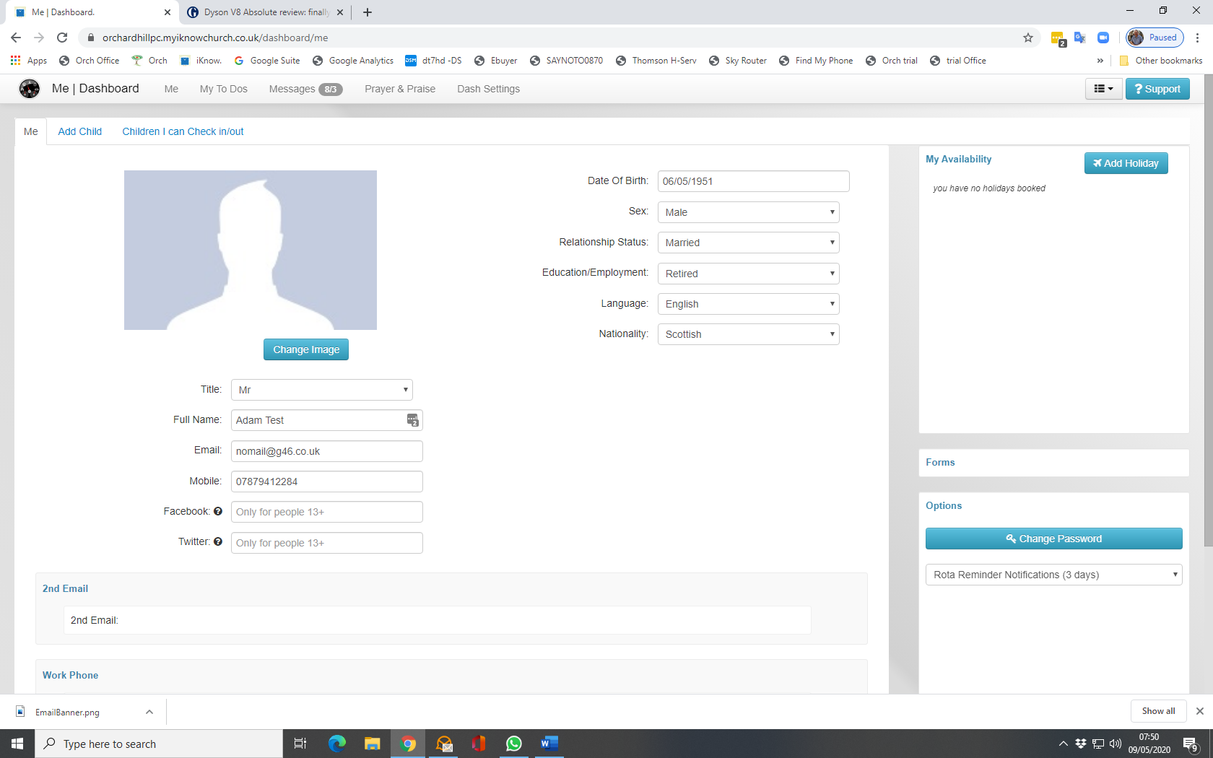
From The main Dashboard you will see in the central part of the page a section called rotas. Here you can click on “Worship Services for Family Morning Worship”. This will display the rota for forthcoming services including the Bible reader, Welcome Team and the collection/count teams. If you are a member of the Media team then you will have different instructions for rotas on Sunday morning.
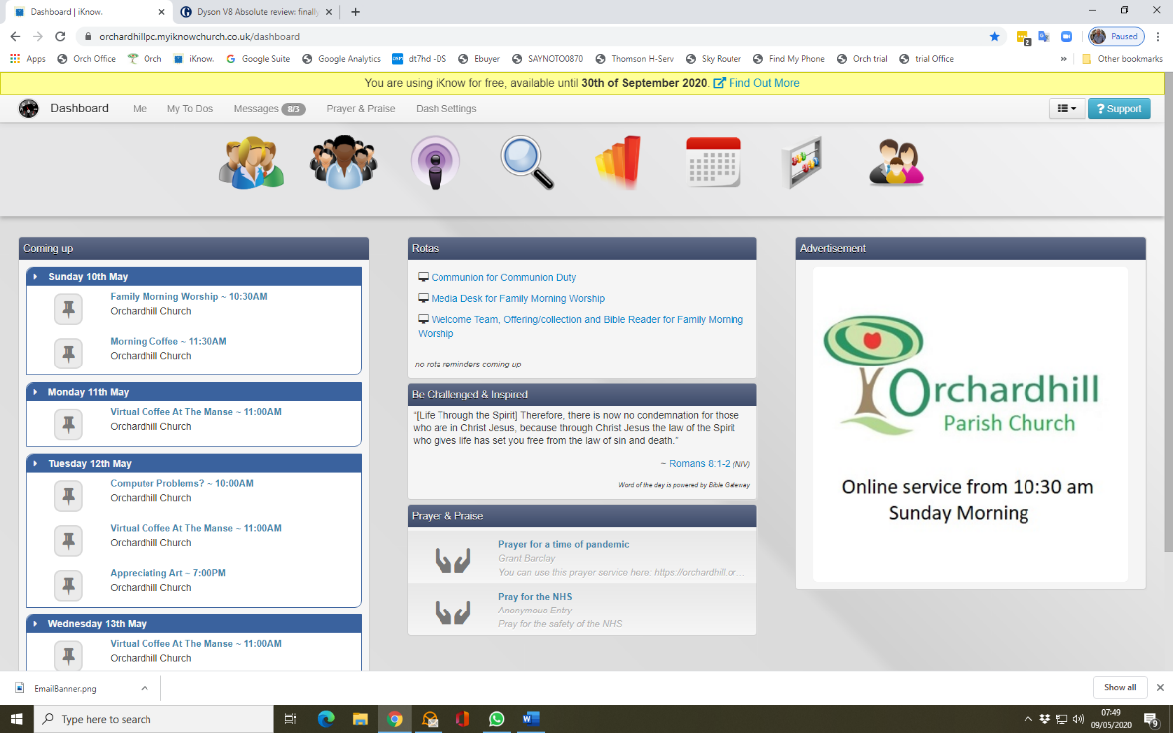
To see what rota teams you are available for the click on the “Teams” Icon on the main icon bar. If you have forgotten to note the times you are not available in “ME” then you can put a request in I share for someone to volunteer for your duty. If you get a response please email Secretary@Orchardhill.org.uk and she will update the rota.
You will also be able to send out an email to everyone on that rota to ask for a volunteer to cover your duty by clicking on view members and contact your team. You can remove certain names from the list before sending e.g. the minister will not do your door duty for you, neither will someone who is on the same duty as you are on.
Finally Groups here you will see all the groups that you can join and also further down the page the groups that you are a member of. Again you can contact your group by email, if you have that permission, by choosing the group and contact group.

Enjoy having a look round I know Don’t forget to add any holidays and rota dates you are not available for and let me know if you have any difficulty with any aspect of I Know Church. Find me on WhatsApp, email, mobile etc.

Dave Thomson
07879412284
Dave@G46.co.uk

